Thuillier Johann 336104120
Bismuth Samuel 342533064

Assignment 3 – Databases

mongoDB :

In the mongoDB folder you can find a code in Java using Maven Central which insert some data in mongoDB.

# Query

use admin;

db.Library.insert( {Book_name : "Harry Potter", Author : "JK Rollwing", Editor : "Folio Junior", Edit_year : 2004, Book : "The book himself download from pdf file in java."} );

# Code in java which insert of the entire book

package org.mongodb.mongoDB;

import java.io.File;
import java.io.IOException;
import java.util.logging.Level;
import java.util.logging.Logger;

import org.apache.pdfbox.pdmodel.PDDocument;
import org.apache.pdfbox.text.PDFTextStripper;
import org.bson.Document;

import com.mongodb.MongoClient;
import com.mongodb.MongoClientURI;
import com.mongodb.client.MongoCollection;
import com.mongodb.client.MongoDatabase;

public class Insert
{
@SuppressWarnings("resource")
public static void main( String[] args )
{
MongoClientURI connectionString = new MongoClientURI("mongodb://127.0.0.1:27017");
MongoDatabase database = new MongoClient(connectionString).getDatabase("admin");
MongoCollection<Document> collection = database.getCollection("Library");
Logger mongoLogger = Logger.getLogger("org.mongodb.driver");
mongoLogger.setLevel(Level.SEVERE);
try
{
String currentFolder = System.getProperty("user.dir");
PDDocument pdf_book = PDDocument.load(new File(currentFolder + "/Harry Potter.pdf"));
String text = "";
if (!pdf_book.isEncrypted())
{
PDFTextStripper stripper = new PDFTextStripper();
text = stripper.getText(pdf_book);
}
pdf_book.close();
Document document = new Document()
.append("Book name", "Harry Potter")
.append("Author", "JK Rollwing")
.append("Editor", "Folio Junior")
.append("Edit year", 2004)
.append("Book", text);
collection.insertOne(document);
}
catch (IOException ex)
{
System.out.println(ex);
}
}
}

# Map reduce

use admin;

map = function() {
var book_words = this.Book.split(" "); // split with your logic.
for (var i = 0; i < book_words.length; i++)
{
emit(book_words[i].length, 1);
}
};

reduce = function(key, value) {
return value.length;
};

db.Library.mapReduce(map, reduce, {out:'reducing'});

db.reducing.find();

# Configuration

please run
mongo < mapReduce.js
from your linux terminal to run the mapReduce.

Neo4J :

# Query in Cypher for neo4j

// Match movies that at least two of Gal's friends liked or watched.

MATCH (g:student{ name:'Gal' })-[:friend*1..3]-(s:student)-[:like |:watch]- >(m:movie)
WITH m, COUNT(DISTINCT s) as num_student
WHERE num_student >= 2
WITH COLLECT(m) as team_movies

// Match movies that Gal watched AND liked that also include in team_movies.

MATCH (movies:movie)<-[:watch]-(gal:student{name:'Gal'})-[:like]- >(movies:movie)
WHERE (movies IN team_movies)
return movies

# Configuration

To verify our query we used deo4j Desktop.
After creating an account, you may be able to create your own database and run our query.

# Screenshots
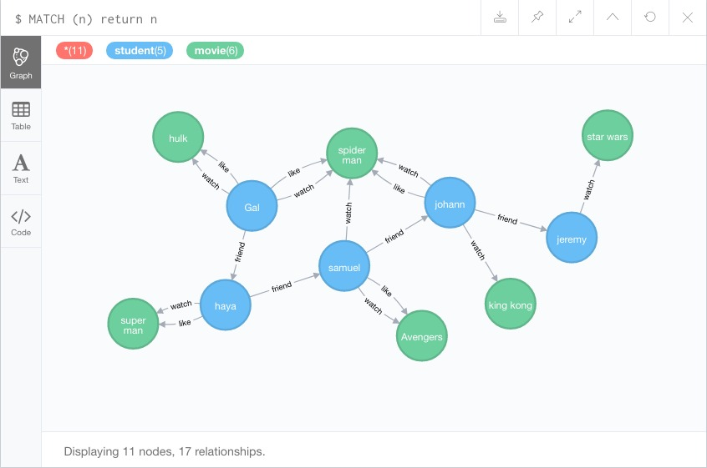
The database using Neo4j desktop.

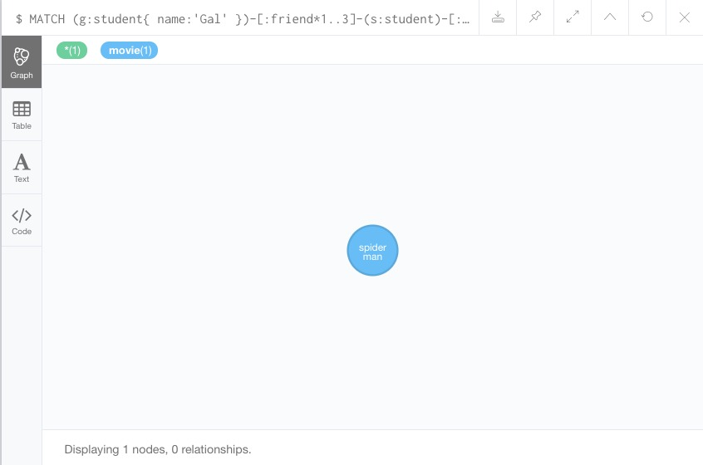
The result query.

ElasticSearch :

# Insert query

POST /books/book/1
{
"title": "Harry Potter",
"Author": "JK Rollwing",
"Genre": "Fantasy",
"Editor": "Folio Junior",
"Edite year": 2004,
"Topic": "You're a wizard Harry."
}

# Search query

GET /books/book/_search
{
"query": {
"bool": {
"must": { "range": {"Edite year": { "gte": 2000 } } },
"filter": [
{ "match": { "Topic": "Science Fiction" } } ,
{ "match": { "Topic": "reality" } } ,
{ "match": { "Genre": "Science Fiction" } } ]
}
}
}

# Configuration

To add the data or seach data you need first to download kibana :
https://www.elastic.co/downloads/kibana
then run ./kibana from thje linux terminal and open the next link in you browser :
http://localhost:5601/app/kibana#/dev_tools/console?_g=()

Then put the query in the console and the data is now added.

# Screenshots

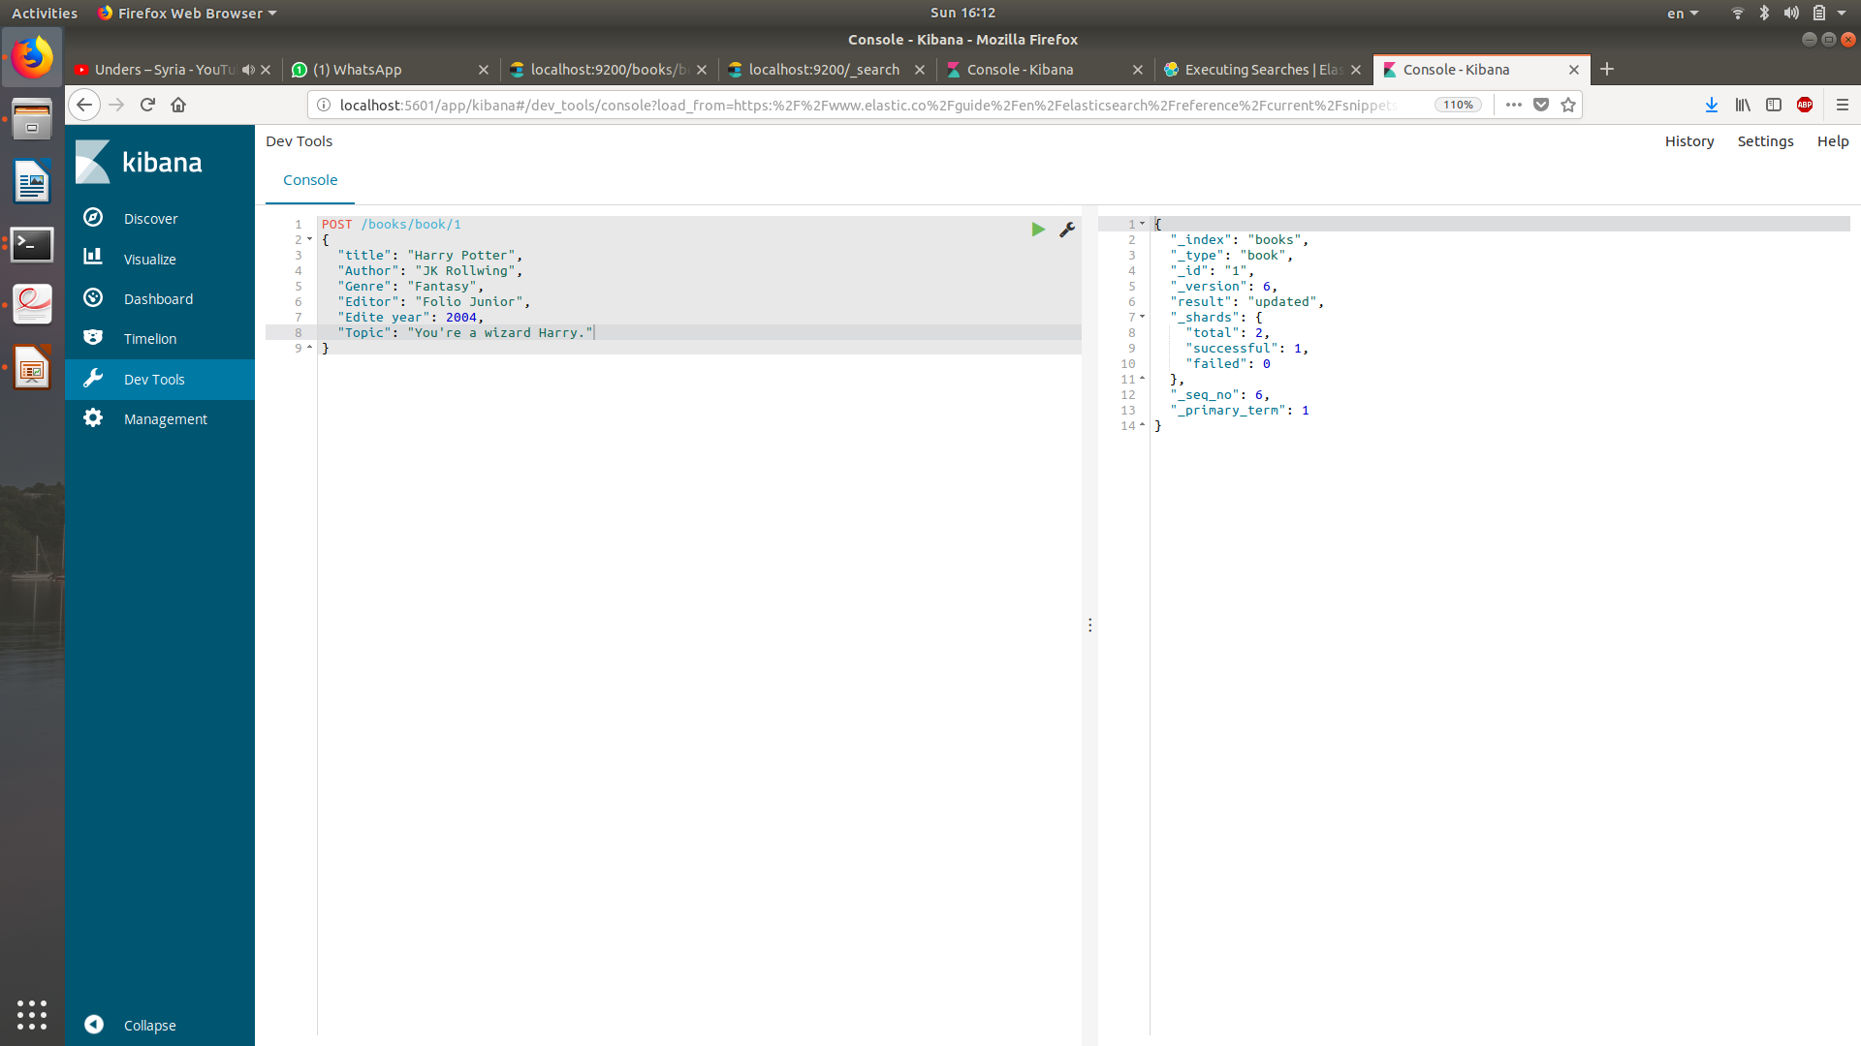
Insert command.

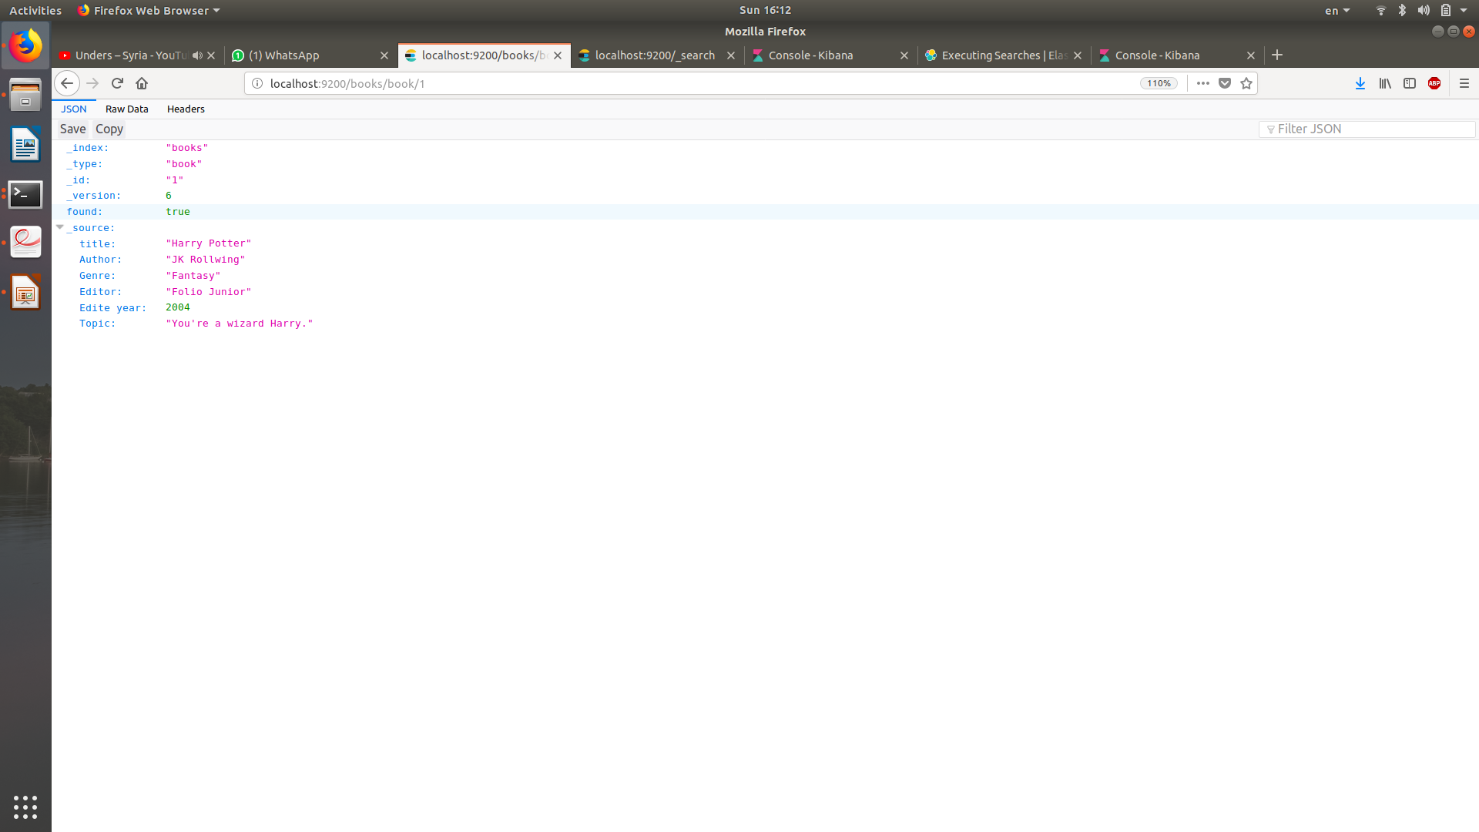
Result of the insert.

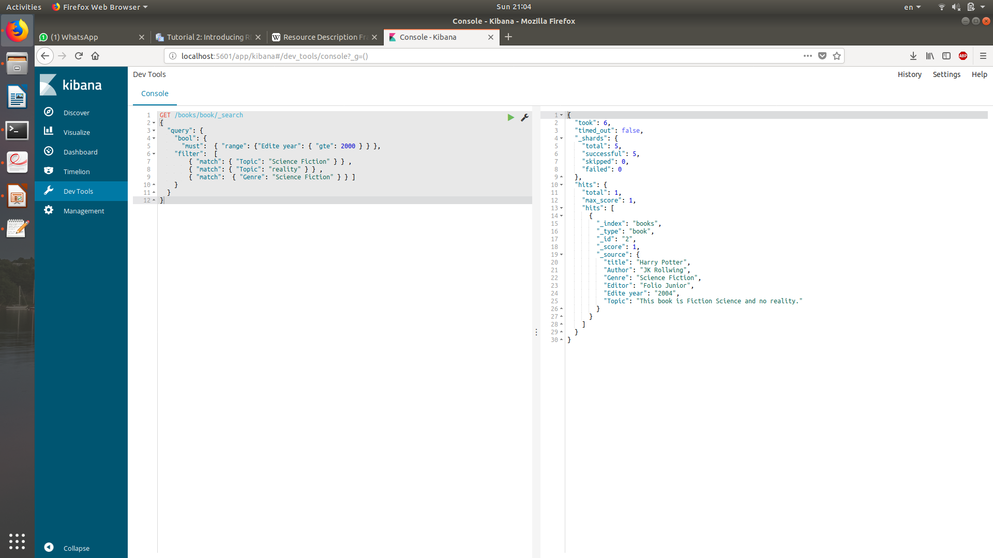
Search command and result.

X-path :

# Query

for $i in //country return $i[sum(city /@num ) > 1000000] /@name

# Xml code for the test

<?xml version="1.0"?>
<root>
<country name = "Israel">
<city num= "1029"> Ariel </city>
<city num = "79833"> Tel Aviv </city>
<city num = "89222"> Jerusalem </city>
<city num = "53728"> Haifa </city>
<city num = "250"> Kokhav Hachakhar </city>
</country>
<country name = "France">
<city num = "62234"> Lyon </city>
<city num = "7373663"> Paris </city>
</country>
<country name = "Espagne">
<city num = "39430223"> Madrid </city>
<city num = "7373663"> Barcelone </city>
</country>
</root>

# Configuration

You can run xpath from this tester :
https://www.freeformatter.com/xpath-tester.html#ad-output
copy the xml file.
Then, compute you xpath code.

Stream :

package stream;

import java.util.Arrays;

public class StreamUse {

public static void main(String[] args) {
Arrays.asList('a', 'b', 'c', 'g', 'H', 'i', 't', 'u', 'v')
.stream()
.forEach(
(c)
->
{
if (c > 'g' && c < 'o')
System.out.println((char) ('z' - c + 'a'));
else if (c > 'G' && c < 'O')
System.out.println((char) ('Z' - c + 'A'));
}
);
}
}

SPARQL & RDF :

# RDF table

S | P | O
cv:111 | tto:name | ttc:ישראל ישראל
cv:222 | tto:name | ttc:‫פלוני אלמוני‬
cv:333 | tto:name | ttc:גון סמיט
cv:444 | tto:name | ttc:ראובן אריאל
cv:111 | gb:age | 15
cv:222 | gb:age | 2
cv:333 | gb:age | 30
cv:444 | gb:age | 81
cv:111 | aws:father | cv:444
cv:222 | aws:father | cv:333
cv:333 | aws:father | cv:444
cv:444 | aws:father | cv:555

# SPARQL query

SELECT ?name
WHERE
{
?person dbp:name ?name .
?person aws:father ?father_variable .
?father_variable aws:father ?grandFather .
?grandFather aws:father ?444 .
}

TF-IDF :

Q: איזה יום היום
1: היום שימשי מאוד בחוץ.
2: היום יום חמישי.
3: ! איזה יום נעים היום
4: היום יום הולדת ליונתן.

Q | היום | יום | איזה | words#
1. | 1 | 0 | 0 | 4
2. | 1 | 1 | 0 | 3
3. | 1 | 1 | 1 | 4
4. | 1 | 1 | 0 | 4
#Doc | 4 | 3 | 1
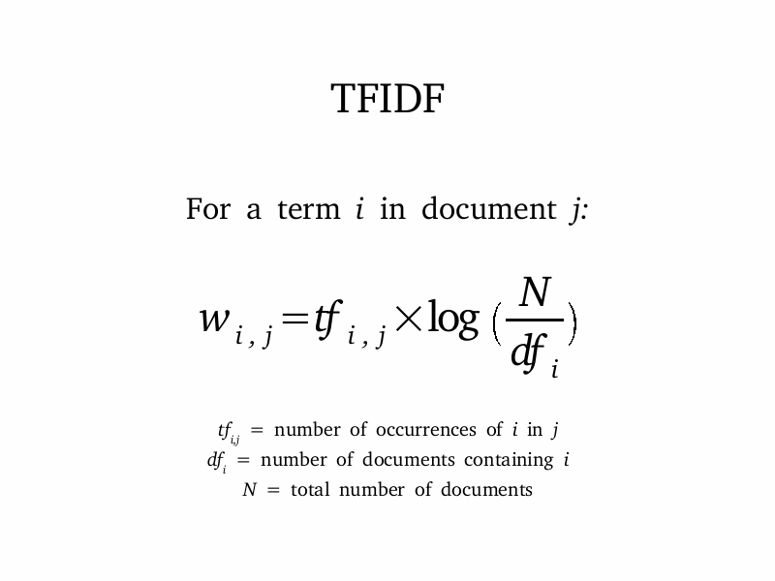

 | Tf Idf score
1. | (1/4)*log(4/4) = 0
2. | (1/3)*log(4/4) + (1/3)*log(4/3) = 0.138
3. | (1/4)*log(4/4) + (1/4)*log(4/3) + (1/4)*log(4) = 0.603
4. | (1/4)*log(4/4) + (1/4)*log(4/3) = 0.103

The third sentence is the most compatible result according to TF IDF.
Source for the formula : http://www.cnblogs.com/youth0826/archive/2012/08/11/2633688.html

